Exercise: HTML CSS3
Document Number: |  | Issue Number:  Date:

TABLE OF CONTENTS
1 Exercise 1: Create a Simple Web Pages with HTML5 and CSS 2
1.1 Description 2
1.2 Create ABOUT US page with Basic HTML5 Tags. 2
1.3 Create OUR SOLUTION page with HTML5 Video 2
1.4 Create WHERE WE WORK page with HTML5 Geolocation 3
1.5 Create SAY SOMETHING ABOUT US page with HTML5 Input tags, HTML5 Web Storage 3
1.6 Create ALL COMMENTS page with HTML5 Web Storage 4
2 Exercise 2: Merge page parts into one 6
2.1 Description: 6
2.2 Create CSS file and let the page link to it 6
2.3 Merge page parts into one 6
3 Exercise 3: Make the website works with difference resolution 8
3.1 Description: 8
3.2 Using CSS3 Media Query 8

Exercise 1: Create a Simple Web Pages with HTML5 and CSS

Description
The purpose of this exercise is to help students get familiar with basic HTML5. At the end of this exercise, students can understand the HTML5 page structures

Create ABOUT US page with Basic HTML5 Tags.
Create a new HTML5 page with content:
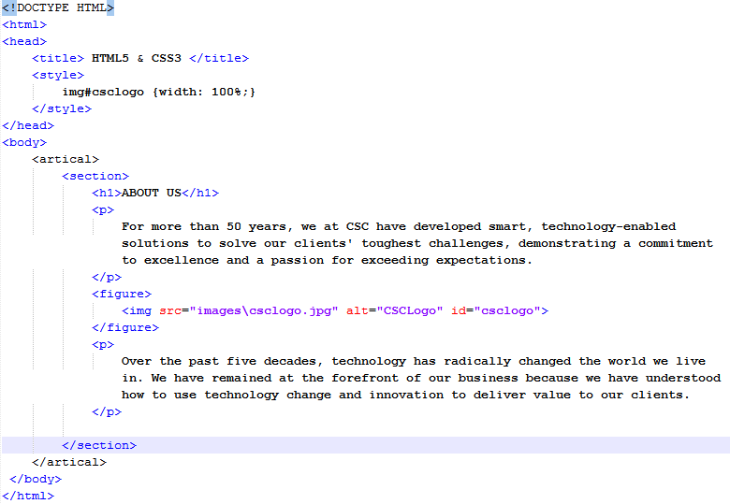

Create OUR SOLUTION page with HTML5 Video
Create a new HTML5 page with content:

HTML

Create WHERE WE WORK page with HTML5 Geolocation

Get Your Position
Create a new HTML5 page with content:
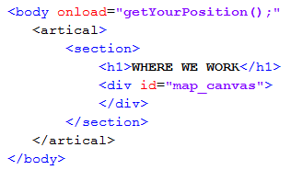
Javascript to get position:
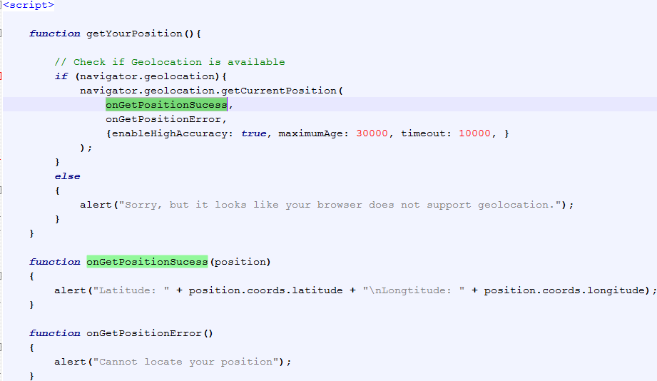

Note: For security, Chrome will prevent Geolocation to work with local page, which display on address bar as “file:///...”. We can use Firefox for this function
If the web page works correctly, the result will be display:
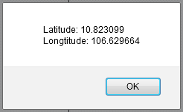

Using Google Map to display your position:
In order to Using Google Map to display the position from above step, we need to include javascript and add some style for map_canvas:
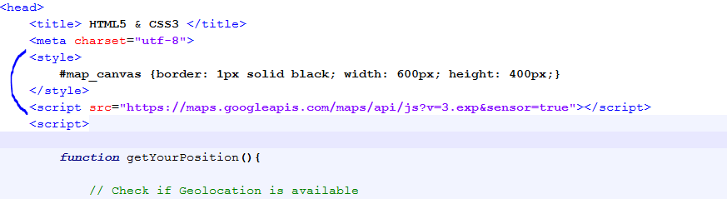
The onGetPositionSucess() function will be:
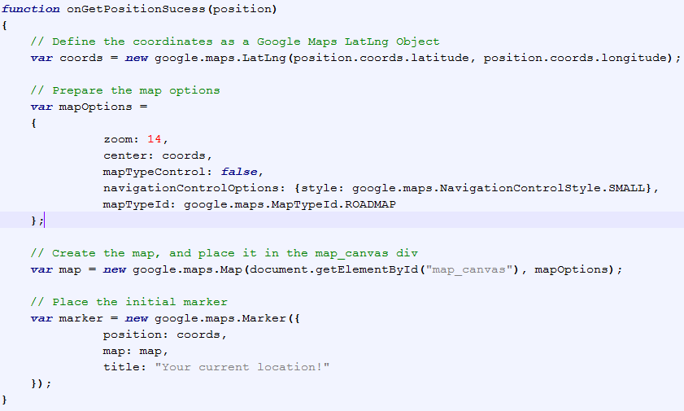

And this is the result:
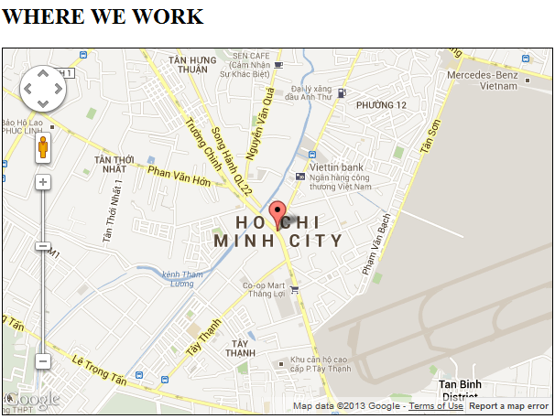

Create SAY SOMETHING ABOUT US page with HTML5 Input tags, HTML5 Web Storage
Description: This page help user post his comment. This comment will be stored in localStorage as JSON string
Create body of the page as following:
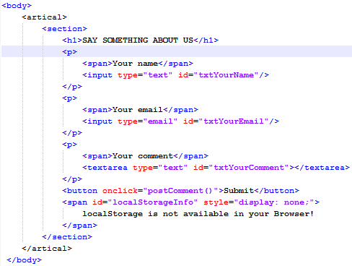
And the head of the page:
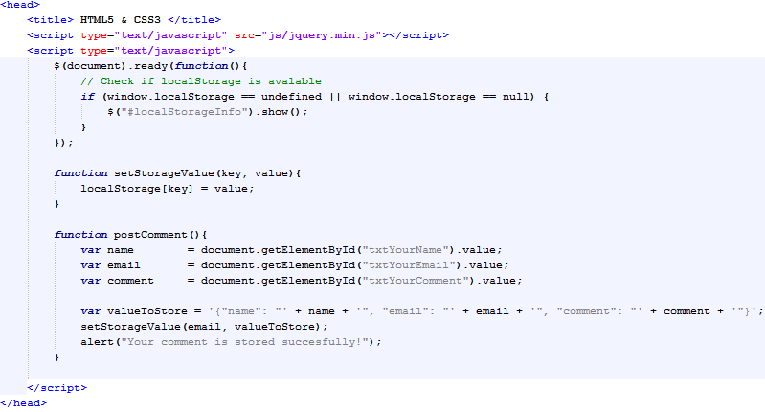
The page will look like this:
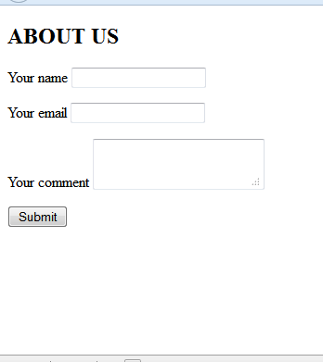

Create ALL COMMENTS page with HTML5 Web Storage
Description: This page will display all comments which users submitted. We will get data from localStorage to display as content of this page.
Create body of the page as following:
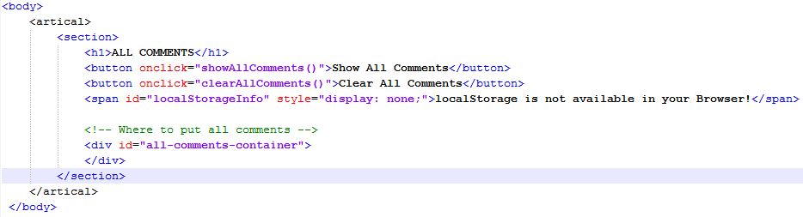
And the head of the page:
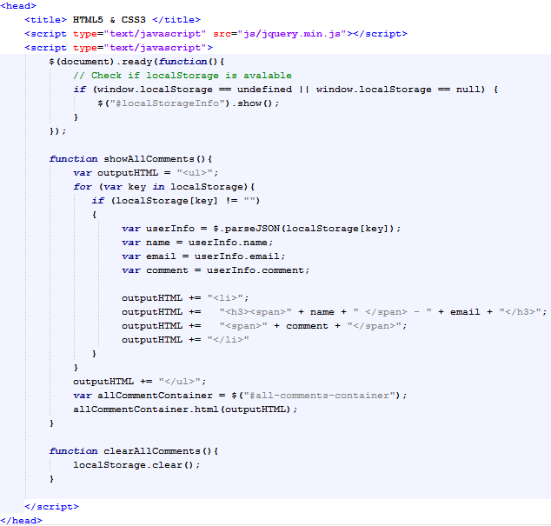
The page will look like this:
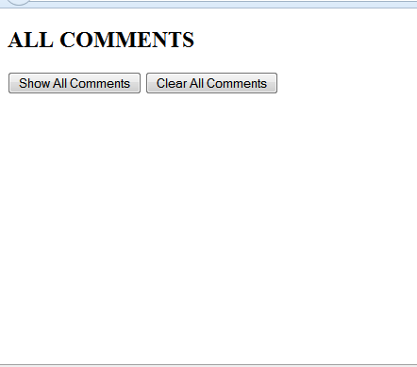

Exercise 2: Merge page parts into one

Description:
The purpose of this exercise is to merge all pages above into one page by applying CSS3. At the end of this exercise, students can understand the CSS3 and how to use it to style a page.

Create CSS file and let the page link to it
Create a new text file, and save as with the name “style.css”, put it into a folder named “css”, this folder is at the same location with ABOUT US page.
Open the ABOUT US page and add link to that css file. The head of ABOUT US page look like this:
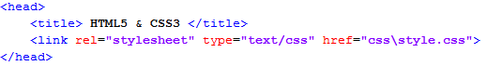

Merge page parts into one
Open these pages:
- OUR SOLUTION
- WHERE WE WORK
- SAY SOMETHING ABOUT US
- Then merge their content into ABOUT US page.
- All css items from those page will be merged into style.css file
Then, we add <header> and <footer> tags into ABOUT US page.
The body of ABOUT US page will look like this:
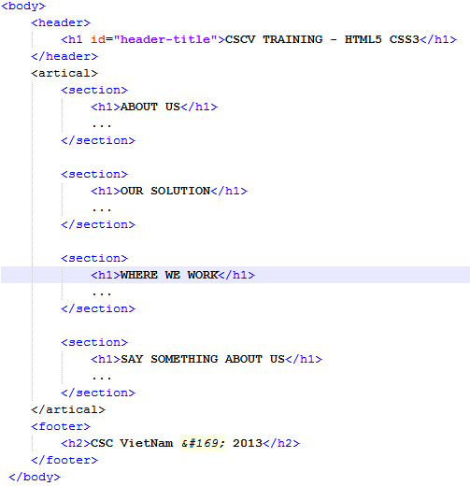

Open CSS file and style elements, the result should look like this:

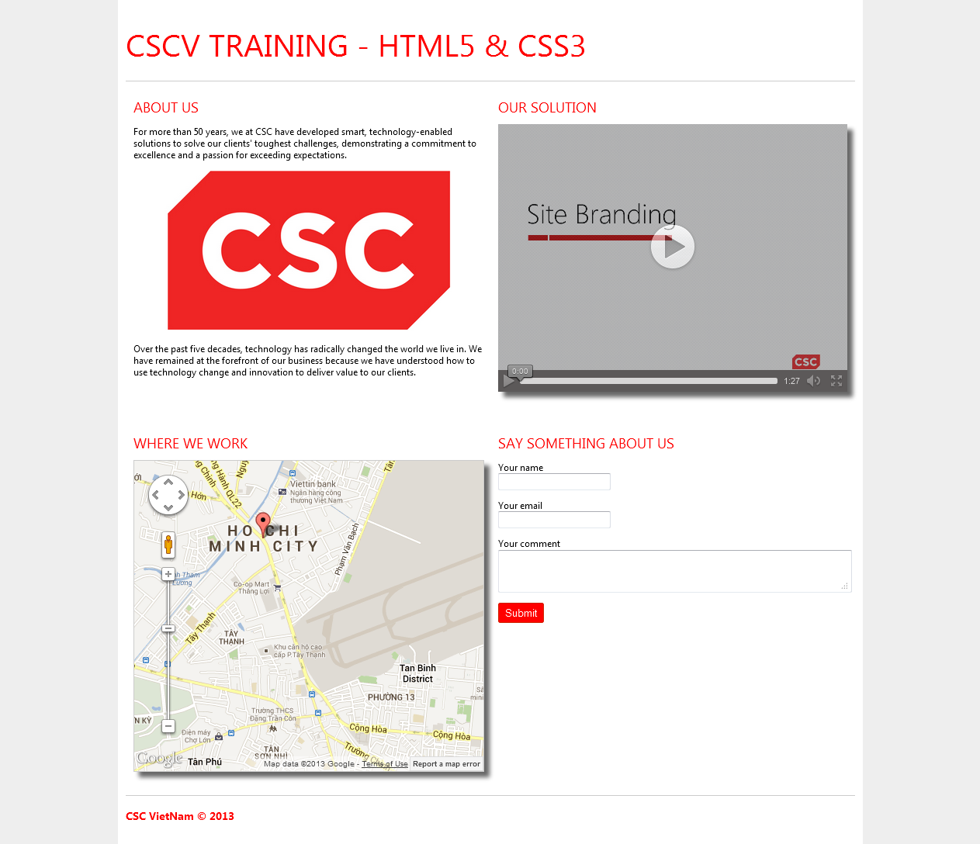

The ALL COMMENTS page:
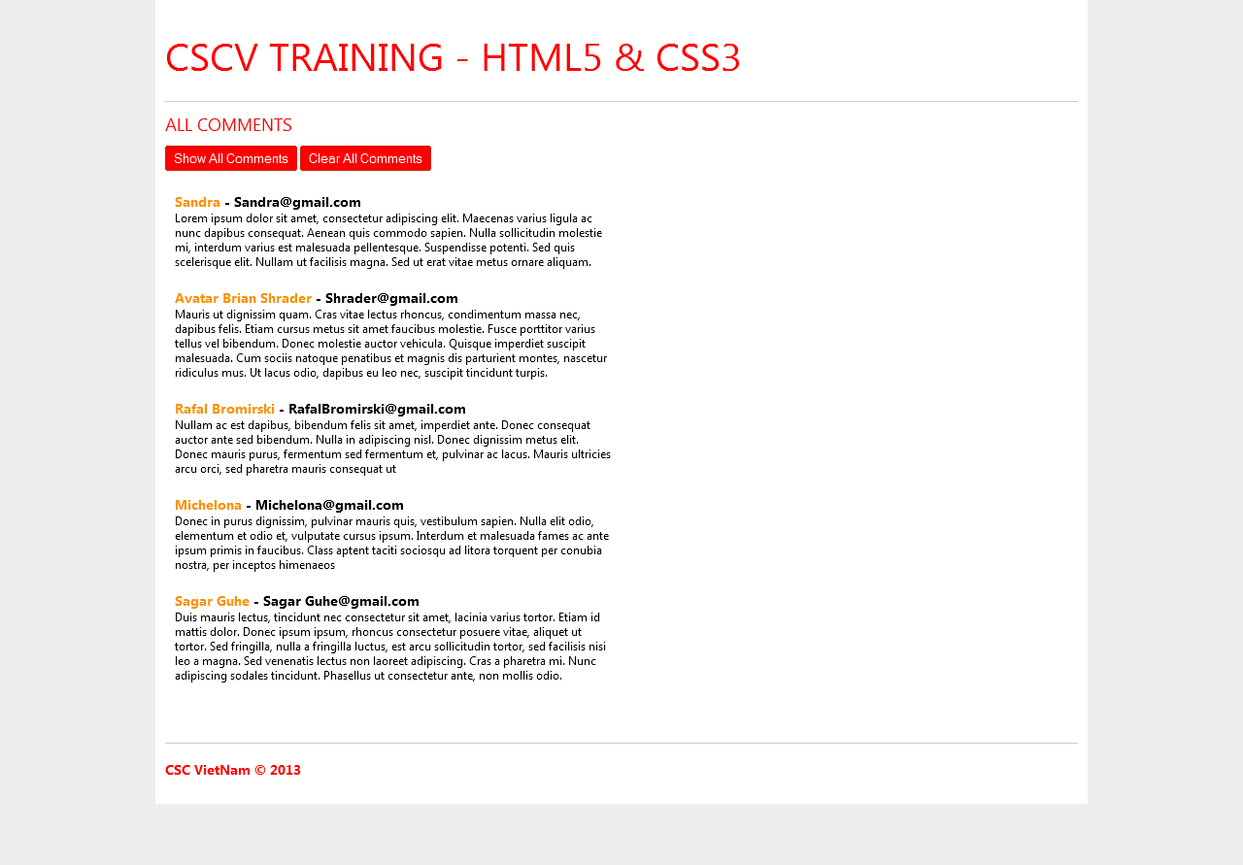

Exercise 3: Make the website works with difference resolution

Description:
The purpose of this exercise is to implement a simple responsive website. At the end of this exercise, students can understand the Responsive web design and how to use it.

Using CSS3 Media Query
We will apply CSS3 Media Query to make the page display flexible with difference screen resolution.

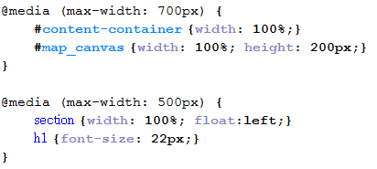
Our goal is to make the page display with small screen as this:

